


Technical Document - Bank Nizwa

1. Executive Summary

Thank you for inviting Zluri to participate in Bank Nizwa. RFP for your Identity and access management requirements. The entire Zluri team is eager to partner with Bank Nizwa, and having carefully considered your requirements, we are very confident we can provide a solution that will deliver significant enterprise operational efficiencies and competitive advantage to your organisation.
In this document, we have detailed how we have structured our response in order to address Bank Nizwa SaaS sourcing requirements and deliver on your desired outcomes. We provide a high-level overview of Zluri’s recommended solution, before then providing justification as to why Zluri is the right choice for Bank Nizwa. As a Saas management solution, we would be addressing the following key solution expectation of Bank Nizwa with the Zluri Offerings:

Bank Nizwa Technical Requirements | Zluri’s Offerings
Identity Governance | Zluri delivers unified, near–real-time visibility into exactly who has access to which applications—whether provisioned via SSO, HRMS, or direct integrations—and lets you slice that data by department, location or business unit. It automatically flags orphaned accounts and provides full app-and-roles for both managed and shadow IT.
Lifecycle Automation | Zluri streamlines your entire employee lifecycle management with automatic provisioning or deprovisioning accounts, groups and licenses across AD, Azure AD, and hundreds of SaaS apps. Workflow rules let you assign access by department, designation or location (even pre-join), while promotions or transfers trigger reevaluation of rights and clean deprovisioning of old entitlements.
Provisioning and Deprovisioning | Zluri’s Integration Catalog and API framework delivers end-to-end automation for user lifecycle events. With 300+ native connectors (Active Directory, Azure AD, Freshservice, and more) plus flexible REST APIs and webhooks, you can trigger provisioning playbooks from HRMS or ITSM in real time. Zluri automatically creates, updates, or deprovisions accounts, group memberships, and licenses according to join-move-leave events, with conditional logic by department, title, or region.
Profile and Role Management | Zluri lets you create and manage access profiles— to build templates of apps, licenses and groups tailored to departments, job titles or regions—and automatically triggers workflows for onboarding, transfers or offboarding via no-code workflows.
Audit and Compliance management | Zluri captures every identity-related event—logins, provisioning, deprovisioning, approvals, reviews and admin overrides on Zluri platform —with timestamped audit logs (user, source, action) that can be exported or fed into SIEMs. All workflows (onboarding, offboarding, access reviews, requests) are fully traceable, with role-based log access to protect sensitive records.
Risk Analysis and Intelligence | Zluri continuously monitors user behavior, app usage and access patterns—detecting inactive or orphaned accounts, and provides details on users who might have over-privileged access and shadow-IT activity by analyzing SSO logs, HR data and financial feeds. It flags anomalies such as unused critical access or cross-functional privileges and leverages AI/ML to recommend remediation: deprovisioning stale rights, right-sizing licenses and suggesting peer-based access models.

Furthermore, we have provided detailed information on the requirements asked by the Bank Nizwa team and have also included core capabilities of the Zluri solution. For the purpose of better comprehension, we have included the relevant screenshots in the response.

Bank Nizwa Requirements

2. Company Profile

Zluri Overview
Zluri is a leading global provider of Identity Governance and Administration (IGA) designed to help enterprises discover, optimize, secure, and automate their SaaS ecosystem. Headquartered in Bangalore, India, with regional offices in the United States. Zluri serves a rapidly expanding international customer base across multiple sectors, including manufacturing, healthcare, technology, education, and financial services. Since its founding in 2020, Zluri has become one of the fastest-growing Identity governance platforms worldwide, recognized by Gartner, G2, and Forrester for its innovation, scalability, and enterprise readiness.

Market Presence & Recognition

Zluri is named in the 2025 Gartner Report Reduce your IAM attach surface using Visibility, Observability and Remediation.

Named a “Leader” in SaaS Management by G2 (2024) for overall performance, ease of implementation, and user satisfaction.

Recognized by Gartner (2023) as a key vendor in the “Market Guide for SaaS Management Platforms.”

Trusted by mid-sized and large global enterprises across North America, Europe, and APAC, including organizations in highly regulated industries.

Strategic partnerships with identity and security leaders such as Okta, Microsoft Azure AD, Google Workspace, and MDM platforms (Jamf, Intune).

Customer Base & References
Zluri’s customers include organizations operating in complex, decentralized environments similar to Bank Nizwa’s global footprint here: Case studies

Key Figures

200+ enterprise customers globally

Managed SaaS spend exceeding USD 2 billion annually

Presence in 30+ countries

300+ integrations across identity, finance, and collaboration systems

Company Overview
Zluri is a global Identity Governance and Administration (IGA) & SaaS Management Platform (SMP) provider that empowers IT, Finance, Procurement, and Security teams to discover, optimize, secure, and automate the entire SaaS stack from a single intelligent dashboard. Founded in 2020, Zluri is headquartered in Bangalore, India, with customer success teams in the United States (San Francisco), United Kingdom (London), ensuring full coverage across APAC, EMEA, and North America.

The company’s flagship platform — Zluri IGA & SMP — provides deep SaaS discovery, license management, spend optimization, access governance, and workflow automation capabilities tailored for medium to large enterprises operating in complex, multi-entity environments.

Key Figures (as of 2025)
Metric | Details
Founded | 2020
Headquarters | Bangalore, India
Regional Offices | Teams across USA
Employees | ~130 globally as of date 1st December
Core Teams | Product Engineering, Data Science, Security & Compliance, Customer Success, Solution Engineering
Customers | 200+ enterprises across 30+ countries
Applications Monitored | 250,000+ SaaS apps globally
Integrations | 300+ pre-built connectors across SSO, Finance, HR, and Collaboration systems
Annual Turnover (FY 2024) | Zluri is a privately held organization.
Industry Recognition | Zluri is Named in the Gartner® Report: Reduce Your IAM Attack Surface Using Visibility, Observability, and Remediation (2025). G2 Leader (2024), Gartner Market Guide for SaaS Management Platforms (2023).

Main Skills and Expertise

Access Governance & Security: Role-based provisioning/de-provisioning integrated with identity providers (Okta, Azure AD, Google Workspace).

Workflow Automation: Access Management - No-code automation builder for IT workflows (onboarding, offboarding, app request approvals).

SaaS Discovery & Shadow IT Detection: Advanced application recognition engine with AI/ML pattern detection and API integrations.

Data Science & Insights: Proprietary SaaS usage analytics model trained on billions of global app events.

Enterprise Integration: Deep native integrations with ERP (SAP, Netsuite), HR (Workday, BambooHR), and MDM platforms (Jamf, Intune).

Compliance & Security: ISO 27001 and SOC 2 Type II certified; GDPR-aligned architecture with regional data residency options.

Team Localization

Product & Engineering (HQ – Bangalore): Core platform design, development, and data intelligence.

Sales & Solution Engineering: Distributed across North America, Europe, and APAC to support global deployments.

Security & Compliance Office (India + US): Continuous compliance management, privacy oversight, and incident response.

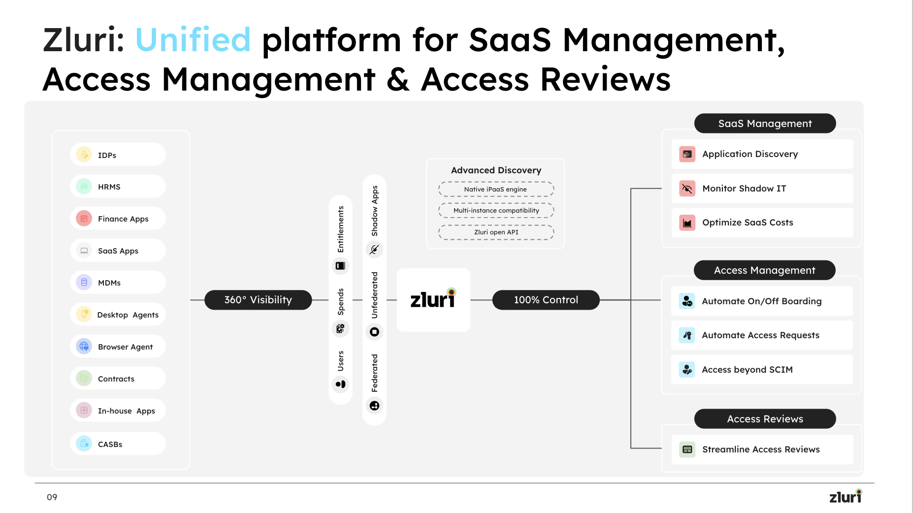
Operational Capabilities and Resources:
Zluri’s Discovery Engine is the central intelligence layer of the Unified SaaS Management Platform, enabling organizations to achieve 360° visibility and 100% control over all SaaS and web-based applications across your environment. Through advanced discovery, Zluri automatically identifies your applications, users, licenses, spends, and entitlements, building a continuously updated SaaS data catalog that acts as a single source of truth for IT, Finance, and Security teams as a centralised Identity and governance solution.

How the Discovery Engine Works

Zluri’s Discovery Engine consolidates data from nine different discovery methods —
Identity Providers (IDPs), HRMS, Finance Apps, SaaS Apps, MDMs, In-house Apps, SDKs and CASBs — to create a 360° visibility layer of all applications, usage, and access patterns.

This data is unified through Zluri’s Advanced Discovery Framework, powered by:

Native iPaaS engine for direct and secure API integrations

Multi-instance compatibility to track usage across multiple subsidiaries or application instances

Zluri SDKs and Webhooks for seamless enterprise Application connectivity with existing tools and workflow automation.

The Discovery Engine identifies:

Federated applications authenticated via SSO

Unfederated and Shadow IT applications accessed directly by users

Usage and Application metrics across departments

Entitlements and User-level access data across systems

This creates a complete, real-time SaaS catalog that helps organizations monitor usage, manage application access and enforce governance policies.
Component | Function
1. Multi-source Discovery | Connects to over 9+ discovery sources including SSO (Okta, Azure AD, Google Workspace), finance (Netsuite, SAP, Expensify), HRIS(workday, Hibob), SaaS Apps, MDMs(Jamf, Kandji), In-house Apps, SDKs and CASBs (Zscaler)
2. Continuous Synchronization | Updated Data via daily data syncs, ensuring the SaaS catalog reflects actual usage across all departments.

3. Zluri Architecture and Technology Details

1. Technical Architecture Overview
Zluri’s platform consists of four primary layers designed for interoperability, scalability, and security:

A. Data Ingestion Layer – “Discovery Engine”
- Connects securely to IDPs, SSO, HRMS, Finance Apps, MDMs, SDK, Saas Apps, CLMs and CASBs via authenticated APIs.
- Collects metadata on applications, users, entitlements.
- Supports multi-instance and decentralized data capture, aligning with Bank Nizwa’s distributed IT model.
- Includes Zluri iPaaS engine for real-time event synchronization across multiple business units.

B. Data Processing & Intelligence Layer
- All collected data flows into Zluri’s SaaS Intelligence Graph, which deduplicates, normalizes, and classifies applications.
- Enrichment engine adds vendor, compliance, and risk attributes to create a live SaaS catalog.
- Utilizes secure cloud-based processing with encryption in transit (TLS 1.2+) and at rest (AES-256).

C. Application & Access Control Layer
- Centralized control plane where global IT can define visibility, policies, and automations.
- Filtered views based on Entities to retain local control over their applications, with configurable data segmentation.
- Integrates directly with IDP and SSO for access validation and optional provisioning/deprovisioning.

D. Presentation & Analytics Layer
- Web-based UI with role-based access for global and local administrators.
- Dashboards for SaaS inventory, access governance, and compliance.
- Exports via CSV and scheduled reports and Zluri API based data exports with Bank Nizwa’s BI tools.

3. Deployment Model
- Type: SaaS (multi-tenant) – hosted on AWS region for GDPR compliance.
- Access: Secure HTTPS web interface; SAML via Bank Nizwa’s chosen identity provider(s).
- Connectivity: Outbound HTTPS connections only — Whitelisting Zluri’s IP is required.
- Scalability: Elastic compute architecture auto-scales based on data volume and user activity.
- Availability: 99.9% uptime SLA with redundant nodes and continuous backup replication.
- Maintenance: Fully managed and updated by Zluri (zero on-prem dependency).

4. Integration Framework
Zluri provides a modular integration framework ensuring interoperability with Bank Nizwa’s systems:
System Type | Examples / Method | Purpose
Identity Providers and SSO | Okta, Azure AD, Google Workspace | User discovery, login tracking,  Secondary application Discovery
HR Systems | SAP SuccessFactors, Workday, Hibob | User lifecycle, department mapping,  Employee Source of truth
Finance Systems | Netsuite, SAP, Concur | Discovering User roles and permissions on important finance applications.
MDMs / Endpoint Agents | Jamf, Intune, Kandji | Device-to-application correlation, Silent deployment of Zluri agents
Desktop and Browser Agents | Zluri lightweight extension | Usage tracking of Local SaaS Applications
Security Tools | CASBs, SIEMs | Zluri Audit log Exports
Zluri SDK | Custom Integration | Support Custom Integration for centralised tracking of Saas Apps and Inhouse apps
All integrations use secure OAuth 2.0 authentication and comply with Bank Nizwa’s internal data governance policies.

5. Security and Compliance
- Certifications: ISO 27001, SOC 2 Type II
- Data Residency: EU-based with options for regional segregation We do host data in the EU but with additional costs.
- Encryption: AES-256 (at rest) and TLS 1.2+ (in transit)
- Access Controls: Role-based with MFA enforcement
- GDPR Compliance: Full data-subject rights management and DPA available

4. Implementation Approach
Zluri proposes a cloud-based, modular, and API-driven technical architecture fully compatible with Bank Nizwa’s decentralized IT environment. Zluri’s implementation cost model is transparent, scalable, and designed to minimize overhead for Bank Nizwa while maximizing value through seamless integrations and automation. The total cost includes platform setup, environment configuration and onboarding support. Discovery Engine is a core strength of Zluri’s platform. Our catalog includes over 300 unique pre-built direct integrations with widely used SaaS and enterprise systems—including Okta, Azure AD, Google Workspace, and Atlassian Admin. These integrations are included at no additional cost as part of the base implementation.
For applications not covered in Zluri’s library, we provide SDKs and REST APIs that enable fast, secure integration with Bank Nizwa’s internal tools or third-party systems—again, without any extra license or customization fees.
Integration Architecture across customers
Here are sample implementation along with architecture diagrams we have implemented across customers

Zluri in Bank of Nizwa’s IT Landscape
Zluri acts as the central governance layer interfacing with:
- HRIS as the source of truth.
- Zluri or ITSM for ticketing and approvals.
- SaaS and other applications for provisioning and deprovisioning.
- SSO Directory services for authentication and federation.
Below is an example diagram but this can be detailed out to any extent as possible during implementation phase -
HRMS
Identity Provider
Zluri
Slack
ITSM
Salesforce
1Password
Gong
Application N

Access Management - Onboarding Via HRMS and ITSM Flow:
- HRMS is integrated as the employee master source.
- On employee onboarding/offboarding/updates in HRMS:
  - Zluri triggers workflows to provision or revoke access.
  - Changes logged and pushed to ITSM for traceability if needed.
Architecture Highlights:
- Webhooks or scheduled polling from HRMS.
- Conditional logic in Zluri workflows based on job title, department, location.
- Use of HTTP actions to interact with ITSM/SIEM tools for audit trails.
Below is an example diagram but this can be detailed out to any extent as possible during implementation phase -
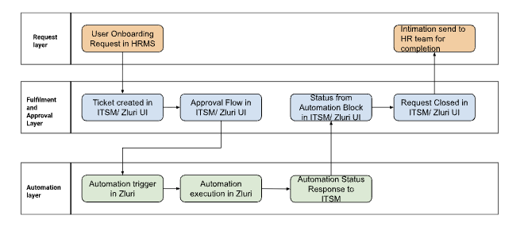
Access Request
Architecture for Access Requests via ITSM or Zluri UI
Flow:
- Users raise requests in the ITSM form, Zluri UI form.
- Once the user raises the request, the approval flow triggers within ITSM or on Zluri and approval takes place.
- Once approval is complete, ITSM triggers Zluri APIs to execute the automation based on the condition of request, or the workflows trigger within the Zluri platform via automations.
Zluri:
Checks entitlement eligibility.
Automates provisioning through connectors/API calls.
Zluri updates ITSM tickets with status and resolution.

Architecture Highlights:
- ITSM custom forms linked to Zluri entitlements.
- Zluri uses HTTP Request action to update ITSM tickets or query approval status.
- Modular workflows built in Zluri for each app.
Below is an example diagram but this can be detailed out to any extent as possible during implementation phase -
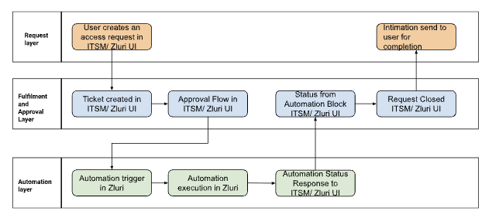
Architecture for Access Reviews
Flow:
- Zluri triggers periodic reviews based on application, user and roles.
- Reviewer receives UI-based access matrix with different entities available within Zluri.
- Reviewer takes action to approve, modify or revoke.
- Revocations trigger deprovisioning workflows in Zluri.
Architecture Highlights:
- Reviewer feedback captured.
- Campaigns are reusable and template-based.
- All actions are logged for audit and closed-loop remediation.
Below is an example diagram but this can be detailed out to any extent as possible during implementation phase -

Certification creation
Certification Reviewers
Closed Loop Remediation
Certification Data Availability Check
Certification Template creation
Timeline and remediation addition
Access Review Certification Trigger
Notification to reviewer for access reviews
Reviewers review basis data
Certificate signoff from reviewer
Certificate signoff from certificate owner
Automation trigger for modification and removal
Certification remediation completion

Certification availability
Certificate available in Zluri to download for Audit and compliance

Implementation costs are typically categorized as:
- Platform Setup & Configuration: Base environment set up and tenant creation.
- Integration & Data Migration: Connecting IDP, SSO, HR, Saas Apps, custom systems.
- Milestone and Phased Implementation: Bank Nizwa’s Scope of Work and Success Goals for implementation is phased and planned and delivered.
- Training & Enablement: Onboarding Bank Nizwa’s IT and business users.
- Support & Maintenance: Ongoing updates, monitoring, and optimization.
Zluri’s flexible model also accommodates integration via Bank Nizwa’s internal IT team, preferred partners, or Zluri’s professional services, ensuring smooth adoption with predictable, all-inclusive pricing and no hidden charges.
Basis agreed upon scope of work, Zluri can provide you with the exact pricing structure. The Customer shall agree to purchase a minimum hours of professional services (the “Minimum Commitment”). These hours will remain valid for use over a period from the Effective Date. Services shall be billed at the rate of USD 60 per hour.
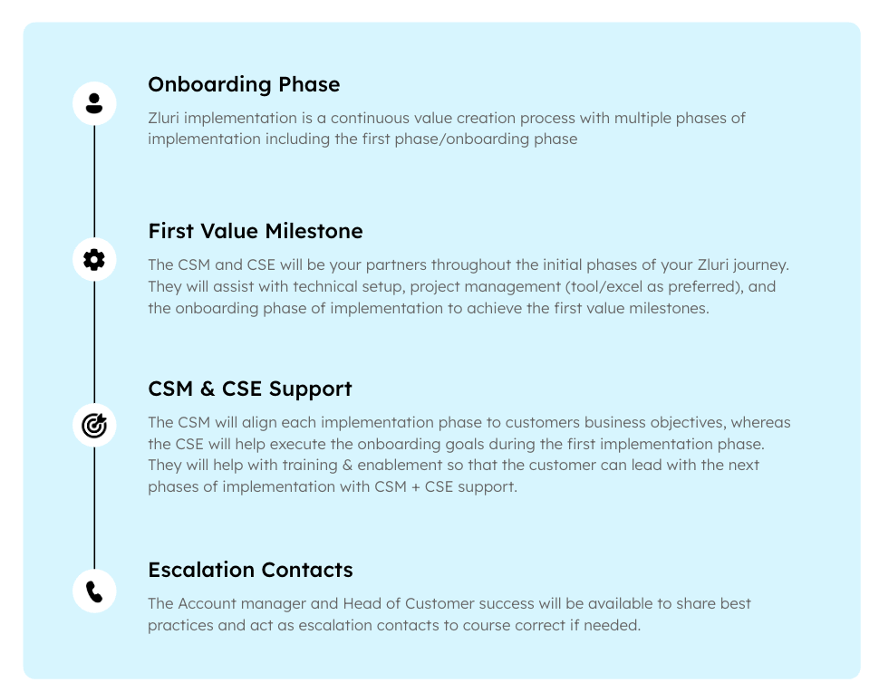

6. Project Timeline
Implementation Schedule and Resource Plan – Zluri IGA Platform
Zluri proposes a structured implementation plan designed to meet Bank Nizwa’s global SaaS visibility, governance and optimization objectives. The schedule ensures fast time-to-value while minimizing business disruption, with clear milestones, internal resource roles, and shared responsibilities between Zluri and Bank Nizwa. The total implementation timeline is estimated at 16–20 weeks for full global rollout, including pilot, data migration, and user enablement.

1. Implementation Phases and Schedule
Phase | Duration | Objectives | Key Activities | Deliverables
Phase 1 –  Project Initiation & Scoping | 2 weeks | Establish governance, scope, and success metrics | • Kickoff meeting with Bank Nizwa PMO and IT leaders  • Define global vs. local scope  • Finalize integration endpoints (IDP, HRMS, Saas Apps, Other Apps) | • Project plan  •Integration matrix  •Project and communication plan
Phase 2 – Environment Setup & Integration | 4 weeks | Deploy Zluri environment and configure top 5 integrations | • Provision Zluri tenant  • Connect IDPs  • Integrate HRMS  • Integrate other applications  • Planning Custom App integration | •Zluri environmental operation  •Data ingestion pipeline live  •Security and access compliance validated
Phase 3 – Discovery & SaaS Catalog Building | 10 weeks | Achieve 100% SaaS visibility across pilot entities and top 5 applications and creation of JML flows, Access Request and Reviews. | • Activate Discovery Engine across pilot subsidiaries  • Data ingestion from identity, and network systems  • SaaS classification and normalization  • Validate discovery results with local IT  • Build live workflows for JML, Access Request and certifications for Access Reviews. | •Validated SaaS catalog  •Shadow IT report  • Initial set of applications for IGA go-live.  •Access Requests go live with approvals and conditions.
Phase 4 – IGA Rollout & Training | 10+ weeks | Scale to more Bank Nizwa entities and train global/local teams | • Conduct workshops for IT, Security  • Create workflows for ULM cycles for Birthright applications.  • Build Access Request for applications  • Enable Access Reviews for few applications.  • Train Bank Nizwa team on the Zluri Platform. | • Global SaaS inventory  • Entity specific filters or visibility dashboards  •Training super users and admins
Phase 5 – IGA Rollout continuation, Operation & Maintenance | Ongoing | Transition to steady-state operation with ongoing support | •Continuous access management and IGA for other applications.  • Access automation configuration  • SLA-based technical support (24×5)  • Periodic review and upgrades | •Quarterly optimization reports  • SLA metrics  •Annual platform review and roadmap update

2. Internal Resources Required (Bank Nizwa)
Role | Responsibility
Zluri Project Manager (IT HQ) | Oversee project governance and coordination with Zluri PM
IT Lead | Validate discovery results, app ownership, and access data
CISO Team | Review data security, access, and policy configurations
HRIS Administrator | Integration of user master data
IT Admin/Teams  CISO Team | Workflow automation and  Access Governance
Zluri provides a dedicated Customer Success Manager (CSM) to coordinate internal and vendor resources, ensuring progress tracking and milestone delivery.

3. Zluri Implementation Team
Role | Responsibility
Customer Solution Engineer | - Configure custom solutions, SDK based data connectors and setting up automation workflows
Customer Success Manager (CSM) | - Customer liaison, user training, and adoption
Director Sales Engineering and Customer Solution | - Technical Oversight Solution Planning, Product feature requests, Solutions Escalation
Customer Success Head | - Customer Success Escalation  - QBR Planning
Support Engineers (24×5) | - Post-go-live technical support

4. Migration, Operation, and Maintenance

Data Migration
- No on-prem dependency; integrations established via secure APIs.
- Data Synced progressively (users, apps, app users, roles, permissions).
- CSV can be bulk-uploaded into Zluri.
- SDK based Custom Integrations Possible

Operation
- Zluri manages hosting, updates, and scaling.
- Bank Nizwa’s administrators manage dashboards, users and reporting.
- Continuous SaaS discovery ensures data freshness with minimal manual input.
- Configuration of automated workflows for User Lifecycle management and access requests by the Bank Nizwa’s team.
- Defining Policies for User access certification and audits

Maintenance
- Zluri handles all patching, updates, and new connector releases.
- Quarterly roadmap reviews with Bank Nizwa to assess new entity onboarding or feature adoption.
- 24×5 support and monthly performance reports (uptime, data sync, integration health).

5. Project Governance and Reporting

Fortnightly project reviews with Bank Nizwa IT and Security teams.

Monthly Steering Committee including CIO, CISO, and Procurement lead.

The RACI model defines accountability for each deliverable (Vendor–Bank Nizwa shared).

All milestones validated by Bank Nizwa Project Leaders before progressing to the next phase.

Governance and Organization
Zluri will implement a structured governance framework to ensure transparent communication, timely delivery, and effective oversight throughout the project lifecycle. A dedicated Project Manager will lead the engagement, supported by a Customer Success Manager and Customer Solution Engineer. Governance will operate on two levels:
- Fortnightly Project Reviews: Conducted with Bank Nizwa’s project team to track progress, review task completion, resolve technical or integration issues, and monitor quality metrics. Each session will include status reporting against milestones, risk logs, and upcoming deliverables.
- Monthly Steering Committee Meetings: Led jointly by Bank Nizwa’s IT Teams, CISO, and Zluri’s senior leadership to review strategic progress, budget alignment, key risks, and change requests. These sessions ensure executive visibility and decision-making support for cross-entity rollout priorities.
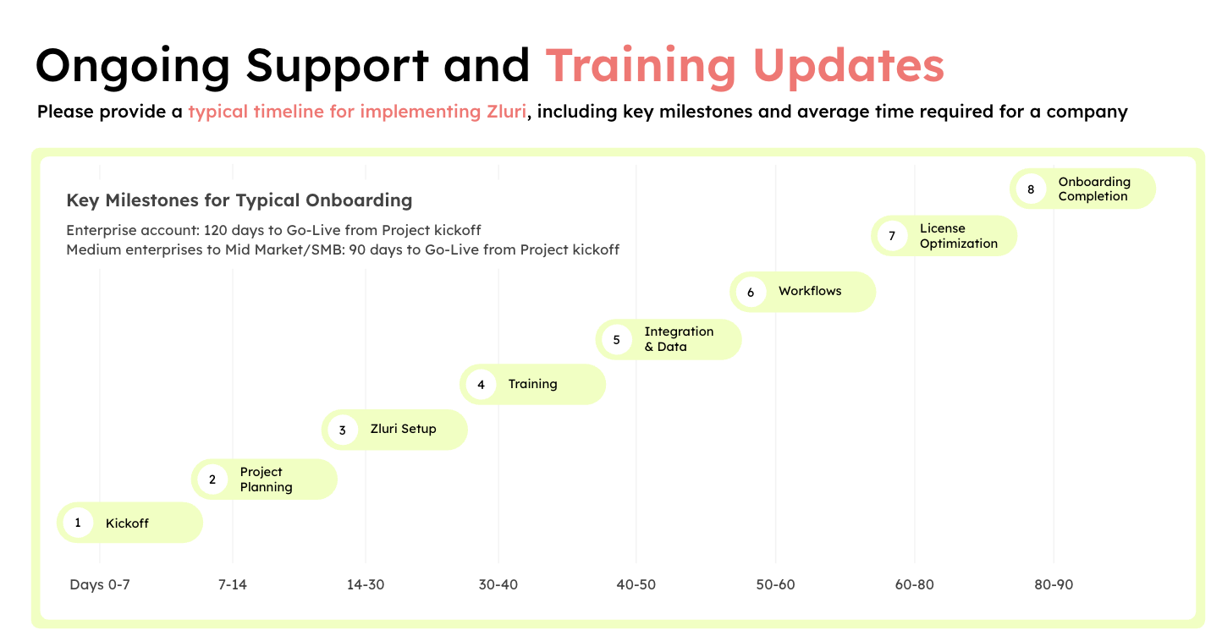
Zluri will provide detailed status dashboards and written reports summarizing key metrics—timeline adherence, data coverage, access automation and issue resolution. All documentation, meeting notes, and dashboards will be shared via a secure collaboration channel. This governance structure ensures accountability, early risk identification, and consistent stakeholder alignment, enabling Bank Nizwa to achieve full user identity visibility, security enhancement, and measurable business value through Zluri’s unified management platform.
7. Governance
Zluri provides Bank Nizwa with a dedicated team of experienced, certified professionals who ensure seamless onboarding implementation, continuous technical support, and proactive solution maintenance throughout the partnership. Our customer delivery organization is structured to provide both technical excellence and strategic guidance, ensuring maximum value realization from the platform.
- Each deployment begins with a dedicated Onboarding Team, responsible for environment setup, integrations, and initial configuration tailored to Bank Nizwa’s decentralized structure.
- A Customer Solutions Engineer works closely with Bank Nizwa’s IT and Security teams to handle technical integrations, data migration, and performance tuning.
- The program is overseen by Zluri’s Director Sales Engineering and Customer Solutions, who ensures technical alignment with Bank Nizwa’s architectural and compliance requirements.
- The Head of Customer Success, who manages long-term engagement, adoption, and ROI achievement.
Post-implementation, Bank Nizwa will have access to 24×5 technical support, including proactive system monitoring, patch management, and regular feature updates. Zluri guarantees 99.9% uptime, with escalation procedures defined under strict SLA commitments. This cross-functional, certified team model ensures that Bank Nizwa receives end-to-end support—from onboarding to ongoing optimization— backed by continuous maintenance, innovation, and an unwavering focus on service quality and customer success.

Zluri SLA
Zluri is fully committed to meeting stringent Service Level Agreement (SLA) standards to ensure consistent availability, reliability, and performance for Bank Nizwa’s global operations. The platform guarantees 99.9% uptime, backed by 24×5 multilingual technical support and defined response and resolution timelines based on issue severity.
- Critical issues (P1): Response within 2 hours, work around within 24 hours.
- Major Issues (P2): Response within 12 hours, response as per the internal defined process.
- Moderate issues (P3): Response within 24 hours, response as per the internal defined process.
- Standard issues (P4): Response within 48 hours, response as per the internal defined process.
Zluri also conducts regular system health checks, performance monitoring, and data integrity audits to maintain optimal service continuity. In case of SLA breaches, Zluri is open to commercial penalties or service credits, demonstrating transparency and accountability in its delivery model.
The platform is hosted on AWS global infrastructure, ensuring redundancy, data security, and compliance with GDPR and ISO 27001 standards. Zluri supports English for customer support. This ensures accessibility and usability for Bank Nizwa’s diverse global workforce, promoting seamless adoption and operational efficiency across all subsidiaries. Please refer to Zluri’s SLA documentation attached.

Relevant Project Deployments

Zluri’s Discovery Engine has been successfully implemented in global enterprises with complex, multi-subsidiary structures, delivering measurable results in SaaS visibility, compliance, access management and access certifications.. - Case studies

Key Differentiators

Accuracy & Breadth: Catalog over 300+ unique SaaS and supports SDK based application Integration— one of the most flexible app recognition libraries in the industry.

Actionable Insights: Converts discovered data into categorized, searchable application catalogs for IT, and Security stakeholders.

Enterprise-grade Scalability: Designed for decentralized environments — supports subsidiaries with local autonomy while maintaining global visibility.

Robust and Scalable Platform – Zluri Identity Governance Platform
Zluri offers a robust, enterprise-grade, and future-ready Identity Governance built to handle the complex, distributed IT environments of global organizations like Bank Nizwa. Zluri’s platform architecture ensures continuous scalability in data ingestion, analytics, user loads, and integration volume, while maintaining enterprise-grade security, performance, and compliance.

Platform Architecture and Scalability
Capability | Description
Cloud-Native Microservices | Zluri is built on a scalable microservices architecture hosted on secure cloud infrastructure with automatic load balancing and distributed data processing.
Elastic Data Pipeline | The Discovery Engine and Analytics layers can scale horizontally to accommodate millions of SaaS usage events and license records without performance degradation.
API-Driven Ecosystem | The platform integrates seamlessly via RESTful APIs and native connectors and SDKs, allowing quick addition of new enterprise systems or custom integrations.
Multi-Entity Design | Supports global organizations with multiple subsidiaries, enabling both centralized visibility and local administrative autonomy.
Modular Expansion | Zluri’s architecture allows independent deployment of modules (SaaS Management, Access Management, Access Reviews), ensuring flexibility as needs evolve.
High Availability and Performance | Uptime SLA of 99.9%, with redundant clusters, automated failover, and continuous performance monitoring.
Security and Compliance | Certified for ISO 27001 and SOC 2 Type II; GDPR-compliant with regional data residency options and encryption at rest and in transit.

Platform Growth Capacity

Data Scale: Proven capability to process and catalog 250,000+ SaaS applications and billions of usage data points across customers.

User Scale: Supports enterprises with 100,000+ active users, maintaining consistent response times under peak load.

Integration Depth: Expanding library of 300+ native integrations, with support for identity providers, finance apps, MDMs, HRMS, CASBs and SDKs.

Continuous Evolution: Monthly feature releases ensure long-term adaptability to emerging IT ecosystems (AI, security, access governance).

